Name: __________________________________ #:_______ Date: _____________________
Social Studies WebQuest
Step 1:
Visit http://www.learner.org/interactives/historymap/index.html
Read the Introduction.
- Click

What is a compass rose?
________________________________________________________________________________________________________________________________________________________________________________________________________________________________________________________________________________________________________________________

A legend, or _____________, can be used to understand the symbols included on the map. _________________, such as lines, colors, or pictures are often used in maps to represent geographical features such as lakes, rivers and mountains.

- Read carefully, study the map CLOSELY. Then click

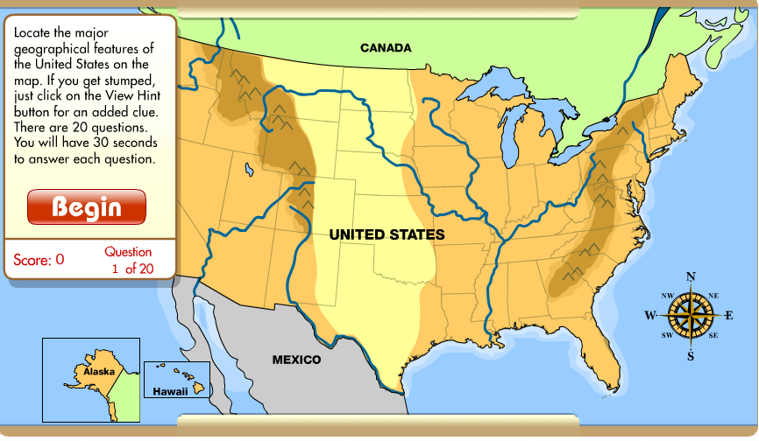
- When you are done, color in the map (stapled) according to directions. Then, Click Move on to the Next Chapter.
Step 2: Click on in the brown bar at the top of the screen underneath the header. Read the introduction.
- Fill in the blank:
Currently, it is thought that the continent’s original inhabitants arrived between ________________and _________________ years ago, after crossing a “____________ ____________” between Asian and North America.
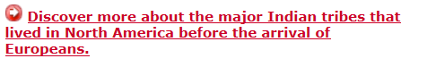
- Click

Arctic Native Americans:
  - Name the tribes:
    - _________________________________
    - _________________________________
    - _________________________________

- What was the climate? ________________________________________________________________________________________________________________________________________________
- What did they eat? ________________________________________________________________________________________________________________________________________________
- What did they wear? ________________________________________________________________________________________________________________________________________________
- List two other facts:
1.______________________________________________________________________
2.______________________________________________________________________

Northwest Native Americans
  - Name the tribes:
    - _________________________________
    - _________________________________
    - _________________________________

- What was the climate? ________________________________________________________________________________________________________________________________________________
- What did they eat? ________________________________________________________________________________________________________________________________________________
- What did they wear? ________________________________________________________________________________________________________________________________________________
- List two other facts:
1. ________________________________________________________________________
2.______________________________________________________________________

Then, click

Southwest Native Americans

  - Name the tribes:
    - _________________________________
    - _________________________________
    - _________________________________

- Read the Pueblo passage.
- What was the climate? ________________________________________________________________________________________________________________________________________________
- What did they eat? ________________________________________________________________________________________________________________________________________________
- What did they wear? ________________________________________________________________________________________________________________________________________________
- List two other facts:
1._____________________________________________________________________
2.______________________________________________________________________

Next, Click
- Read ALL passages. Then answer the questions.
  - Name the tribes:
    - _________________________________
    - _________________________________
    - _________________________________
    - _________________________________
    - _________________________________
    - _________________________________
- What was the climate? ________________________________________________________________________________________________________________________________________________
- What did they eat? ________________________________________________________________________________________________________________________________________________
- What did they wear? ________________________________________________________________________________________________________________________________________________
- List two other facts:
1.______________________________________________________________________
2.______________________________________________________________________

Click on
- Read ALL passages. Then answer the questions.
  - Name the tribes:
    - _________________________________
    - _________________________________
    - _________________________________
    - _________________________________
    - _________________________________
    - _________________________________
    - _________________________________
    - __________________________________
- What was the climate? ________________________________________________________________________________________________________________________________________________
- What did they eat? ________________________________________________________________________________________________________________________________________________
- What did they wear? ________________________________________________________________________________________________________________________________________________
- List two other facts:
1.______________________________________________________________________
2.______________________________________________________________________
Click on
- Read ALL passages. Then answer the questions.
  - Name the tribes:
    - _________________________________
    - _________________________________
    - _________________________________
    - _________________________________
    - _________________________________
    - _________________________________
- What was the climate? ________________________________________________________________________________________________________________________________________________
- What did they eat? ________________________________________________________________________________________________________________________________________________
- What did they wear? ________________________________________________________________________________________________________________________________________________
- List two other facts:
1.______________________________________________________________________
2.______________________________________________________________________
Step 3: Play Identify the Tribe. Put your score here: ___________________

